**RPM (Red Hat Package Manager)**

1)RPM (Red Hat Package Manager) is originally developed by Red Hat and most popular package management utility in linux Platform.

2)RPM is distributed under the terms of the GPL(General Purpose License)

3)RPM provides a standard way to package software for distribution.

4)It allows the administrator to track where files are installed by the software package and which one needs to be removed.

5)Package management system takes all the various files containing programs and data, documentation and configuration

information and places them in one specially formatted file a package file, with an extension of ".rpm"

**Package Identification:**

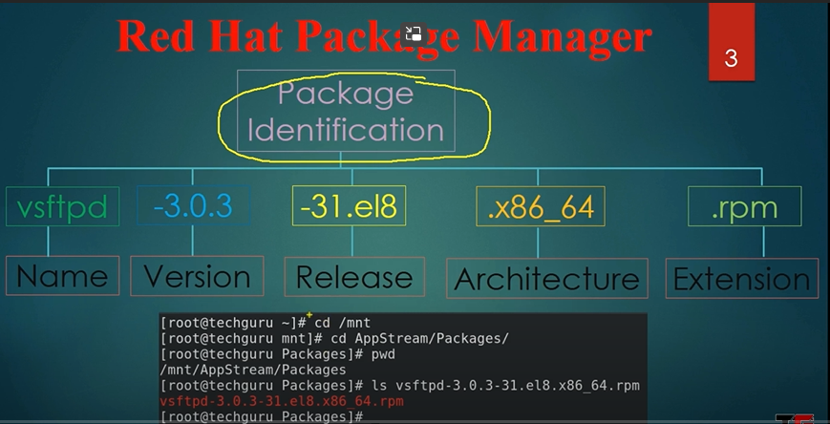

RPM packages are available in two locations.

1)Appstream/Packages –If package relate to software then those packages are in appstream

2)Base OS Packages –If packages are os related then those packages in BASE OS

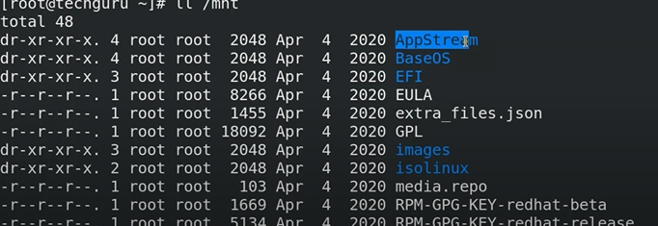

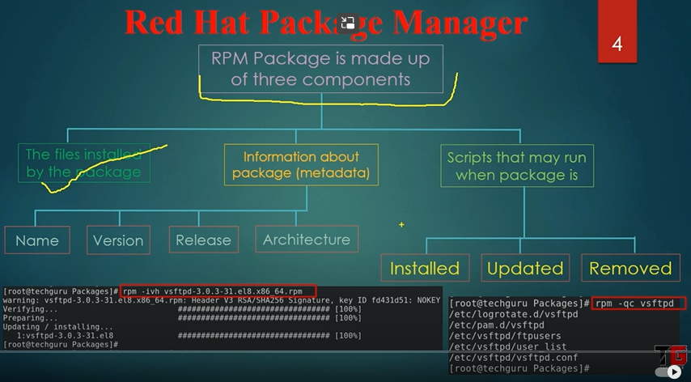

**RPM (RPM Package Manager)**

RPM is a popular package management tool in Red Hat Enterprise Linux-based distros. Using RPM, you can install, uninstall, and query individual software packages. Still, it cannot manage dependency resolution like YUM. RPM does provide you useful output, including a list of required packages. An RPM package consists of an archive of files and metadata. Metadata includes helper scripts, file attributes, and information about packages.

RPM maintains a database of installed packages, which enables powerful and fast queries. The RPM database is inside /var/lib, and the file is named __db*.

Some commonly-used modes are listed below:

|  |  |
| --- | --- |
| Mode | Description |
| -i | Installs a package |
| -U | Upgrades a package |
| -e | Erases a package |
| -V | Verifies a package |
| -q | Queries a package |

To install or upgrade an .rpm package using RPM, issue this command:

rpm -i package-file

rpm -U package-file

rpm -ivh package-file

The flag -i is for install, U is for an upgrade, v for verbose, h for hash (this option displays the # as a progress bar for the operation). In this example, v and h are optional flags.

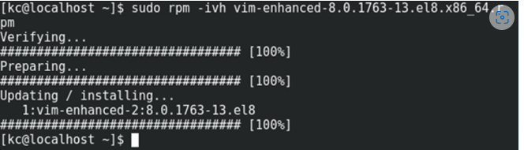

To query for a package using RPM issue following command:

rpm -q query-options package

rpm -qa vim-enhanced

Option a queries all installed packages on the system.

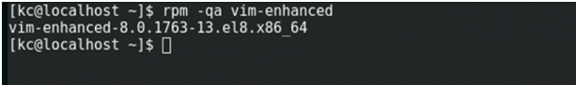

To erase a package, use the following command:

rpm -e erase-options package-name

rpm -evh vim-enhanced

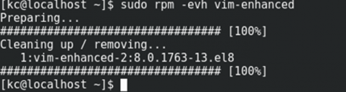

How to check configuration files?

rpm –qc vsftpd

